# HTML 5 Programming for .NET – Self-Starter Kit

## Hands-on Programming for HTML 5

The below mentioned are HMTL 5 hands-on activity which needs to be carried out in PRP training for User experience batch,

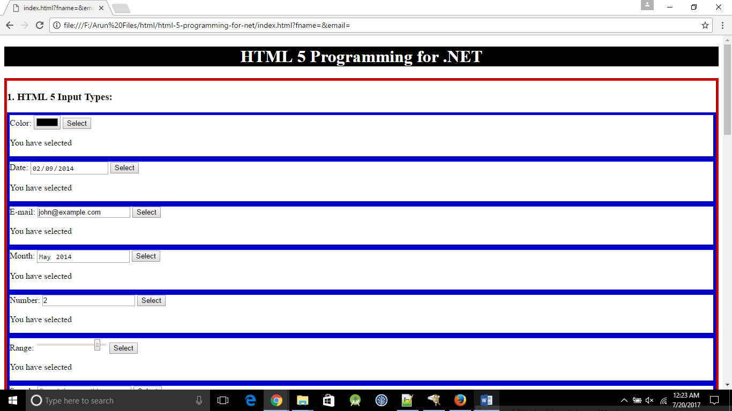

Figure Visual of input types -1

1. **HTML 5 Input Types:**

* Design a web page with below mentioned rich HTML 5 input controls to accept inputs,

Color, date, email, month, number, range, search, tel, time, url , week

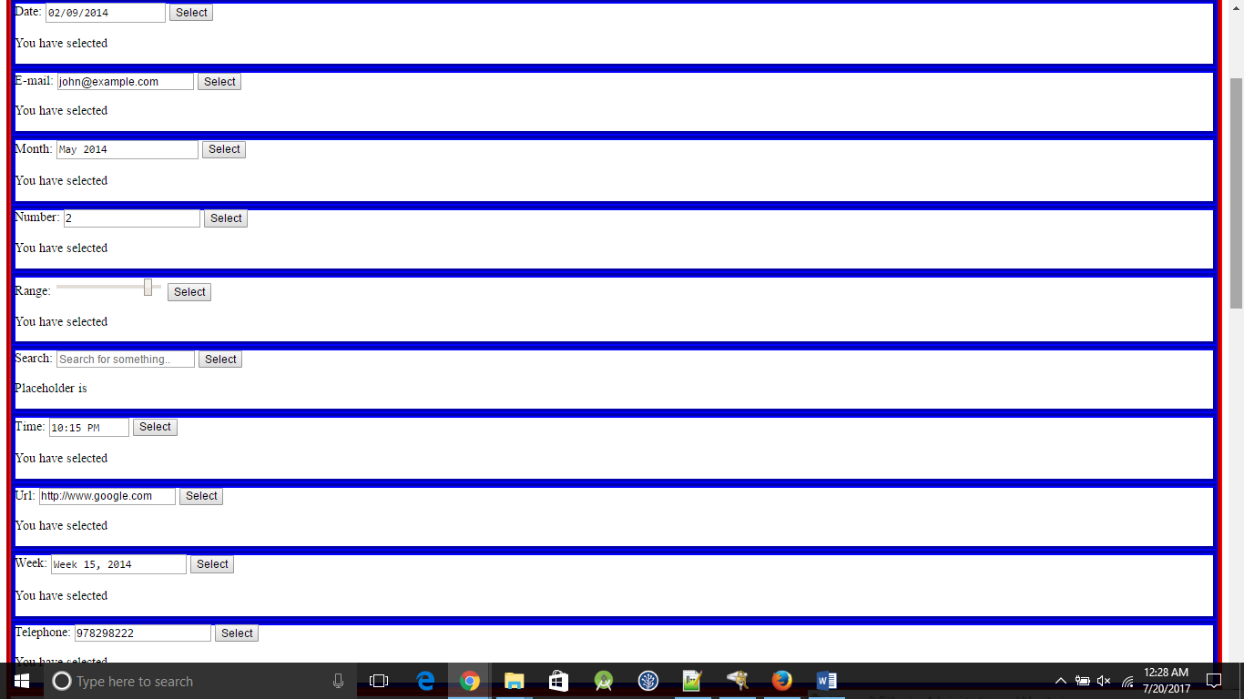

Figure visual of input types -2

1. **HTML 5 Form Elements:**

* Design and implement a web page with below mentioned new HTML 5 Form elements,

Datalist, keygen

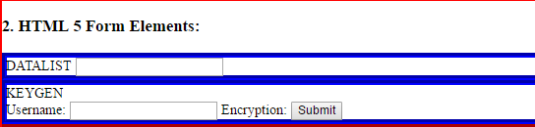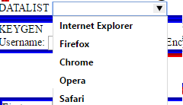

Figure form elements

1. **HTML 5 Form Attributes:**

* Design and implement a web page with below mentioned new HTML 5 Form attributes for <form> tag
  + Autocomplete, novalidate

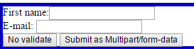

Figure Auto complete no validation form

* Design and implement a web page with below mentioned new HTML 5 Form attributes for <input> tag
  + - Formenctype, formnovalidate, formtarget



Figure target

* + min and max attributes, multiple, pattern, placeholder, required, step

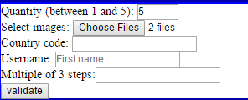

Figure other attribute

1. **HTML 5 <canvas>:**

web page using <canvas> tag for drawing any graphics on the fly, color the objects by providing coordinates

.*Figure 7 canvas cloud drawing*

1. **HTML 5 Drag and Drop:**

Design and implement a web page to implement a drag and drop feature in HTML 5 (Drag one object in web page from sou5ce location to destination location in a web page).



Figure drag WIPRO logo to empty box

1. **HTML 5 Video and Audio:**

Design and implement a web page to display audio and video files. This media files should be embedded in a web page.

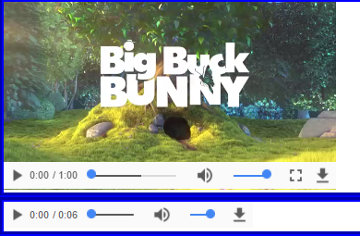

Figure video and audio screenshot